SUBMISSION
FOR CONSIDERATION BY THE
BROADCASTING AND LEGISLATIVE
REVIEW PANEL

January, 2019

“The world needs to know about Canada … and
Canadians need to know about Canada too.”
- Stompin’ Tom Connors,
Morningside,
CBC Radio, 1996

“The world’s audiovisual heritage is endangered ….
Its disappearance would represent an irremediable impoverishment of the memory of the world.”
- Irina Bolovka,
Director General,
UNESCO, 2010.

The CBMF/FMCR was federally incorporated on January 3, 2001. Governed by a Board of Directors drawn from the broadcasting industry and the heritage sector, it is committed to finding the best contemporary solution for the collection, preservation and celebration of Canada’s broadcasting heritage, encompassing radio, television and screen-based services in French, English, indigenous and other languages, and to ensure public access to this significant cultural record.
We emphasize the following essential elements for your consideration.

- It is imperative to safeguard the essential role of communication within local communities and across the regions where Canada’s vital national culture is being forged;

- We must ensure that the challenges of geography do not limit our ability to communicate with each other and celebrate the experience of being Canadian, and

- It is essential to address the creation and operation of a National Media Repository for Canada, and enshrine its responsibilities in legislation to ensure long-term preservation of the historic documentary records contained in our analogue and digital media.

The Foundation is convinced that our broadcasting system – the most advanced communications technology of the day – supported the development of a unique Canadian culture in the 20th century. Our interest in legacy radio and television programming is founded in our belief that safeguarding Canadian culture will also depend on our ability to access the past as well as on reliable, predictable communications services that will allow us to engage with and enlighten each other in future.

I The State of Our Communications System: HOW DID WE GET HERE?
In the closing months of 2018 Canada finds itself confronting the greatest communications challenge it has faced in a century of massive technological change.
Decades ago Canadian engineers figured out how to build a transmitter system to deliver radio service to a small population scattered across the world’s second largest national land-mass. Then we harnessed that system to keep Canadians in touch with the million family and friends soon engaged in the war effort across this country and abroad.
In the 1950s we met the challenge of television – in two languages – tapping into Canadian creativity and imagination to create programs and series that drew millions of viewers each evening and held their own against the blockbuster product of our southern neighbour.
Expanding choices for information and entertainment, we became the world’s most cabled nation and, with the launch of ANIK in 1972, an early-adopter of satellite signal delivery. Optical fibre replaced coaxial cable, greatly expanding the channel and service options available in urban Canada … and then the game changed.
In the early ‘90s, Tim Berners-Lee developed the computer-based communications system known as the World Wide Web and, since then, we have scrambled to shore up our broadcasting infrastructure, reluctant to acknowledge the inevitable cultural and industrial implications presented by this new medium.
The opportunities created by the Web - now renamed ‘the Internet’ – leap-frogged over decades of national policies and regulations designed to support creators of Canadian cultural products, be they magazines, books, music, film or the programming provided by our broadcasters.
In 2000, a group of prescient creators and broadcasters recognized that the continued existence of Canadian radio and television media was seriously threatened. The distinctive culture that had evolved north of the 49th parallel was at risk and, in the face of industry consolidation, it became apparent that the decades of recorded programming in station and network libraries and program archives – the electronic record of Canada’s evolution from the 1920s onward - was in jeopardy.
Research revealed the startling fact that Canada was the only developed nation with no integrated, formal process to preserve its complex radio and television legacy. Neither legislation nor regulation imposed on public or private broadcast licensees requires conservation of this electronic record of our national or regional, social and political evolution, nor was any federal institution – not even Library and Archives Canada - charged with or resourced to undertake this comprehensive cultural responsibility.
Geographic realities meant that extension of service (i.e., bringing radio and television service to communities scattered between the three oceans) had to be the priority – and it remains a remarkable achievement. But with the future of Canada’s broadcasting system clearly at risk, the CBMF/FMCR was federally incorporated in 2001 to address the issue of long-term preservation of and access to the broadcast record of our national evolution.
See Appendix A for a review of the significance of preserving original media.

II PRESERVING OUR CULTRAL HERITAGE AND PROVIDING PUBLIC ACCESS - A CANADIAN SOLUTION
In the years since its creation, the Foundation has explored options for crafting an efficient Canadian preservation process, worked with broadcasters and producers to determine the scale of need and, as keeper of last resort, beginning the assembly of the National Broadcast Collection for Canada.
In the last decade, destruction by electro-magnetic pulse attack has replaced nuclear blast as the principal threat to the electronic documentary record. Digital media are especially vulnerable. Developed nations have begun to focus on subterranean facilities for conservation of their legacy media:
- Britain has redeveloped the underground nuclear warhead storage facility near Gaydon in Warwickshire for preservation of its film and television collection.
- The program archives of Switzerland’s seven public radio and TV services (SRG and SSR) are safeguarded in tunnels dug deep beneath the Alps and repurposed from their original wartime application.
- In America, PBS preserves its unique programming collection of analog video and film in a decommissioned mine near Kansas City.
- In 2014, New Zealand transferred responsibility for preservation of some 600,000 hours of original NZ radio, television and film dating back to 1895 to Ngā Taonga Sound & Vision which had developed secure custom-built vaults.
- The program collections of Germany’s broadcasters are now preserved in a restored World War II subterranean hospital complex.
- Much of the United States’ early audiovisual record of radio, film and commercial television is protected in a secure environment beneath a mountain in northern New York State.
- and the Hollywood majors whose films are now ‘born digital’ convert those digital masters to analog 35 mm film because it’s a safer. More stable way to protect their long-term investment. Along with much of America’s music masters, they are stored in a former salt mine 22 storeys below Butler County, Pennsylvania.
Earlier this year, this country was faced with an immediate challenge: the preservation of eight decades of radio and television programs paid for by the people of Canada and held in trust for them by the CBC/R-C. The Corporation has begun to digitize much of its French and English-language programming but, unlike Radio-Canada, CBC English Services had no interest in preserving its analogue program master-recordings post-digitization.
Had the analogue masters not been retained, Canada would have become the first developed nation to systematically destroy the historic record contained in its collection of original program recordings.
The Foundation attempted to negotiate a delay in destruction of these collections to allow time for completion of an alternate plan already underway. When the Corporation refused to consider a postponement, ACTRA and the Friends of Canadian Broadcasting joined the Foundation in a national online campaign that saw in one week more than 19,000 emailed expressions of concern land on the desks of the CBC’s EVP - English Services, the Minister of Canadian Heritage and, later, each member of the CBC’s Board of Directors.
We have now been assured there is a three-year moratorium on destruction of any of the CBC’s archived program masters.
Section 46 (1)(j) of the 1991 Broadcasting Act requires that the CBC/R-C “publish, distribute and preserve, whether for a consideration or otherwise, such audio-visual material, papers, periodicals and other literary matter as may seem conducive to the attainment of the objects of the Corporation.” Our renewed public broadcaster must be assigned the same responsibility. As it continues to serve the public interest on all its platforms with news, information and programs that are the product and expression of the creative arts, it must be assigned at least shared responsibility for long-term preservation of this factual and artistic program collection.
It is critical that this vast record of our national evolution be both preserved to international heritage standards and, subject to expiration or negotiation of the applicable rights, be made permanently accessible to Canadians by appropriate digital means.

III WHERE TO FROM HERE?
This Panel was charged with study of the changes necessary to safeguard Canada’s communications system by then Minister of Canadian Heritage, Mélanie Joly, with an expectation that it will report its findings and recommendations by the end of January, 2020.
There is, in fact, no certainty that Canada’s English-language private sector TV networks will remain viable for that long.
For decades, CTV and Global have relied on carriage of popular American TV series in prime time to boost their commercial revenue (through the unique Canadian regulatory tool of simultaneous substitution). But a number of American services are planning to begin streaming their programs in early 2019. That fact may limit the availability of such programs for purchase by Canadian networks as well as significantly decrease their appeal as part of a network TV schedule. It will undoubtedly have a negative affect on Canadian TV audience numbers and on the already declining commercial revenue confronting CTV and Global television.
During the “Let’s Talk TV’ hearings in 2014, TV executives made the CRTC aware of their willingness to hand back network licences in the face of continuing revenue losses. The Commission’s own figures are evidence that, in the intervening few years, this trend has not reversed. Currently, private sector television operations are being subsidized by their parent companies’ success as ISPs and, given their fiduciary responsibility to deliver a positive return to investors, it would be foolhardy for them not to consider the option of network closure.
In the long-term, this may in fact be inevitable and for that reason we believe it is now essential to consider the re-invention of Canada’s communication system
Graham Spry, one of its founders, saw the role of the national public broadcaster as the central nervous system of a country. In an address to the Royal Society of Canada, he pointed out that, “Without communication there is no society, be it a hive of bees, a troop of boys scouts, a Bar Association or a nation.”
In the face of global competition and soaring production costs, we must take care to ensure that Canadians’ ability to communicate, to share their concerns and celebrations is not obliterated … or confined to the individual, un-curated expressions of social media.
Decades ago, the CRTC’s founding Chair, Pierre Juneau, warned us that,
To preserve and develop our ability to create and produce our own imagery is something we simply cannot do without. To enable ourselves to see
everything, including ourselves, through our own eyes and our own systems of production and diffusion, will require a long and persevering effort.

This is not the time for surrender. Your examination of the legislative infrastructure is setting the stage for the next chapter in Canada’s evolution, a challenging but not impossible task. It will require no less effort and imagination that did the Aird Commission’s exercise of 1929, and should result in design of a contemporary national communications structure for Canada, the skeleton of which must be based on a revitalized, appropriately resourced national public media service.

The extent of change likely to affect Canada’s broadcasting and telecommunications industries in the next decade means that reconfiguring communications system and the critical responsibilities of the national public broadcasting service in it will involve an uncommon level of complexity, especially in respect to issues of governance and regulation. Given the intricacy of current governance issues involved and the need to be nimble enough to respond to rapidly changing circumstances, it may well be time to search the world for models of best practice that can ensure the funding, the management and governance of this our national public broadcaster, a key cultural institution, are established for success.
In fact, failure to do this is not an option. We respectfully suggest that, well before submitting its final report to government, the Panel undertake or commission a study to assess the applicability of best practices that can be tabled for public discussion before final recommendations are placed before government.

IV CULTURE, SOVEREIGNTY, DEMOCRACY … AND COMMUNICATION

Sometimes looking backward can be instructive.

More than three decades ago, the Caplan-Sauvageau Task Force undertook yet another examination of how our Federal broadcasting policy should be changed to better serve Canadians.

During that process the Minister of Communications, the Hon. Benoit Bouchard confronted the key issue on October 16, 1985:

Just as retaining our territorial sovereignty is essential, if we are to remain an independent nation, so it is true that we must always retain our cultural sovereignty …. How could we call ourselves a truly sovereign nation if we were as to relinquish our sovereignty – our undisputed right to act, in those areas which are the essence of a nation: its culture and its means of communicating with itself?

Later that same day, it was again Pierre Juneau, by now President of the CBC/Radio-Canada, who perhaps best articulated the key relationships between culture, sovereignty and the national broadcasting service.

Culture is how a country plays, rejoices and laughs. It is also how it expresses its dreams and hopes, how it sees and talks about its past and its future…. Like life itself, it is infinitely diverse. Like life, it constantly evolves…. Culture is also innovation, creation. It is inspiration for the present and the future. It is confidence…. It is independence and freedom. It is sovereignty of the mind, what makes one nation equal to another.

Culture is the very heart of sovereignty. There can be no political sovereignty, therefore no authority over our own lives and our own future, without cultural sovereignty.

Broadcasting is not just an element or section of culture. It is the most powerful mirror or manifestation of our culture….It has become the principal theatre, the principal disseminator of news, the principal vehicle for entertainment in this country. It has become the national performance stage and the national forum for information and news.

Broadcasting is the most powerful instrument we have to bring Canadian culture to all Canadians. That is what public broadcasting should be. To a large extent it is what the CBC is. That is what the CBC will be if we as a nation want it to be.

As we approach the end of the second decade in the second millennium, we know that, no matter what their language of choice, the voices of Canadians and the products of their many talents are a minority in North America. Moreover, our advanced technical infrastructure brings to most Canadians an unmatched choice of information and entertainment sources.
But we also know that, despite the similarities we share with other North Americans, we are a distinct people. Culture evolves in ways that reflect the priorities of its civil society. A healthy, predictable system of national communication is the key tool in ensuring Canadians are able to determine - and sustain - those unique cultural elements that will define their nation in the 21st century and beyond.
In the event that private sector carriers are no longer able to support local, regional or national communications, it will remain the responsibility of the Government of Canada (and a vibrant national public media service) to ensure the operation of all aspects (analogue and digital) of our cultural birthright is maintained.
With that objective in mind, we offer for the Panel’s consideration, suggested wording for the next iteration of Section 3, Broadcasting Policy for Canada.

V REVISING THE BROADCASTING POLICY FOR CANADA
The comments and proposals contained in this submission are premised on continued national support for key principles in existing legislation. Suggested revisions to reflect contemporary cultural and technical Canadian realities are offered below.
I - As modified for application in the contemporary international digital environment, these include:
- that the Canadian communications system shall be effectively owned and controlled by Canadians;
- that the Canadian communications system makes use of radio frequencies in the electromagnetic spectrum that are public property;
- that, taken together, the domestically-owned public and private sector components provided by the Canadian communications system constitute a public system essential to the maintenance and enhancement of national identity and cultural sovereignty;
- that as technology permits, equitable access to service across all regions be developed;
- that the Canadian communications system, operating primarily in the English and French languages, shall provide access to domestic and foreign services in these and other languages as enabled by technology and resources;
- that English and French domestic components of the Canadian communications system share common aspects but operate in different conditions and must be capable of responding to different cultural and other imperatives.

II - Further, the domestic elements of the Canadian communications system shall
- safeguard, enrich and strengthen the social, cultural, political and economic fabric of Canada;
- encourage the development of Canadian expression by providing a wide range of services whose content reflects Canadian attitudes, opinions, ideas, values and artistic creativity, by displaying Canadian talent in entertainment programming and by offering information and analysis concerning Canada and other countries from a Canadian point of view;
- through the content and employment opportunities it provides, serve the needs and interests, and reflect the circumstances and aspirations of all Canadians, including equal rights, the linguistic duality and multicultural and multiracial nature of Canadian society and the special place of indigenous peoples within that society;
- be readily adaptable to scientific and technological change;
- contribute in an appropriate manner to the creation and presentation of Canadian programming and ensure its accessibility to disabled persons as technology and resources permit,
- make no less than predominant use of Canadian creative and other resources in the creation and presentation of programming, unless the nature of the service provided by the undertaking, such as specialized content or format renders that use impracticable, in which case the undertaking shall make the greatest practicable use of those domestic resources;
- be responsible for the content they offer to the public, shall ensure it is of high standard and that, for as long as technologically possible, programming of national and regional significance is preserved in its original format as part of the documentary record of Canada.

III - The programming provided by the Canadian communications system shall
▪ be varied and comprehensive, providing a balance of information, enlightenment and entertainment for people of all ages, interests and tastes;
▪ be drawn from local, regional, national and international sources;
▪ include on all platforms Alert Ready, the national emergency alert service;
▪ include educational and community services that are acknowledged to be an integral component of Canada’s communications system;
▪ include programming that reflects the indigenous cultures of Canada;
- provide a reasonable opportunity for the expression of differing views on matters of public concern, and
▪ include a significant contribution from the Canadian independent production sector.

IV - The national public media service (NPM) shall be available for reception by all Canadians on radio (audio), television (video) and digital platforms and, to the greatest extent possible, capitalize on new and emerging technologies to provide a wide-range of programming that informs, engages and enlightens audiences. As custodian of much of Canada’s broadcast record, it shall play a central role in preservation of our continuing audio and video legacy.
The programming provided by this service shall
▪ be predominantly and distinctively Canadian;
▪ be available for reception by all Canadians;
▪ be non-commercial and delivered free of advertising content except where acknowledgement or sponsorship is required to enable carriage of significant programs;
▪ to the greatest degree possible make all its video services available in both official languages; its audio and digital services shall be in English and in French, with all services reflecting the different needs and circumstances of each official language community, including those of English and French linguistic minorities;
▪ ensure, in its provision of factual programming, public access to insightful, impartial and accurate news and current affairs coverage of domestic and global issues to facilitate public participation in Canada’s democratic process;
▪ contribute to shared national consciousness and identity, and reflect Canada and its regions to national and regional audiences, while serving the special needs of those regions,
▪ actively contribute to the flow and exchange of cultural expression and reflect the multicultural and multiracial nature of Canada, and
▪ strive to be of equivalent quality in English and in French.

VI NATIONAL RESPONSIBILITY FOR PRESERVATION OF
LEGACY PROGRAMS

With agreement-in-principle that Canada too must address the need to preserve and provide public access to its ever-expanding inventory of programming (now mostly born digital) that constitutes the audiovisual record of our national development comes the requirement to assign responsibility and define jurisdictions.

Decades of investment have built for this country one of the world’s most effective legacy institutions, Library and Archives Canada (LAC/BAC). Already charged with responsibility for legal deposit of film and video material when independently produced with support from Telefilm Canada or the Canadian Media Fund, its current resources are stretched to the limit and clearly insufficient to permit wholesale transfer to it of a national undertaking of this scale. For this reason, the CBMF/FMCR has proposed to the Government of Canada a public/private partnership that would permit multiple levels of participation and investment in a comprehensive Canadian media repository, with LAC/BAC as the Federal lead.

Little change to LAC/BAC’s enabling legislation would be required.

It already provides that “documentary heritage means publications and records of interest to Canada” and “record means any documentary material other than a publication, regardless of medium or form.” Taken together, these definitions will simplify extending LAC/BAC’s institutional responsibility to the development and operation of a national media repository.

With support from the Department of National Defence and the Department of
Canadian Heritage, the CBMF/FMCR is developing a proposal to transform the
mothballed underground former NORAD headquarters in North Bay, Ontario into a
world-class media preservation facility. An engineering assessment to determine the scope of remediation required will be undertaken this winter. If findings indicate
this site is a practical option, its development could take Canada from the back of
the pack to substantive leadership with a state-of-the-art media preservation facility
that will safeguard the audio-visual record of our shared history. The next step
will be to harness contemporary technology to ensure Canadians have permanent
online access to this unique and historic national collection.

Additional background on this plan is attached in Appendix C.

VII CONCLUSION

This panel has been charged with recommending to Government the changes required
to provide the legislative infrastructure on which can be constructed a contemporary
communications system responsive to Canadian needs. It is a complex and
challenging task that must address present day requirements as well as being readily
adaptable to those unknown technological and social imperatives that will surely arise in future.

Re-thinking details of the system’s structure and the legislative changes required to
reflect 21st century realities must constantly be assessed against the fundamental role
of communications in sustaining our unique culture, identity and existence as a
sovereign nation in a globalized world.

In that context we have attempted to document here relevant elements of our media
history, in the hope that this opportunity will allow Canada to remedy a critical gap in
heritage policy as it relates to our unique system of broadcasting and communications.

The CBMF/FMCR appreciates the opportunity to participate in this process and would be
pleased to provide additional information, should that be helpful.

Douglas Thompson
Chair, CMMF/FMCR

APPENDIX A

Why Preserve Program Originals?
THE SIGNIFICANCE OF MASTER RECORDINGS

Radio and television programs are 20th and 21st century creative products whose social and historical importance is comparable to that of cultural artefacts from earlier times such as manuscripts, paintings and music scores. Their preservation and society’s continued access to them will be critical strands in the design of Canada’s evolving national landscape.
After Gutenberg invented the printing press around 1440, access to the content of most manuscripts increased over the centuries. Arguably, the practical need for them – and for their preservation – could have been minimized by the existence of multiple printed sources. But, in fact, the historic significance of manuscripts as a testament to social evolution grew, influenced by both their rarity and their artistry
Today, no one would think of destroying the Codex Leicester, the Uthman Qur’an or the Stockholm Papyrus because modern copies (even digital ones) are readily available.
The same holds true for the world’s inventory of images, from the caves at Lascaux to the San rock painting in Lesotho, the frescos in the temples and tombs of ancient Egypt, the wonders of 6th century Sui dynasty landscapes or Europe’s Renaissance masterworks, to the unique representations of Canada by Krieghoff, Carr, Thomson or Riopelle. Around the world their work is digitally accessible at a tap on a keyboard - yet the originals are no less valued. They continue to be preserved and treasured as important components of humanity’s shared heritage.
Radio and television are 20th century media, the electronic manuscripts and recorded images of people and events in one of the most transformative periods in human history. Their familiarity makes it easy to dismiss them but they are of no less historic and creative value than their aged predecessors. While the perspective of decades is lacking, it is our generation’s responsibility to ensure that these original records of Canada’s social and cultural achievement is preserved.
It is also important to consider that each communication medium is generally less permanent that the one it succeeds, with the most lasting of all being stone tablets and prehistoric cave paintings! Technologists of the day have constantly laboured to preserve each preceding format, be it (inter alia) parchment, canvas, paper, nitrate film, acetate or DAT tape.

Today’s digital wizardry is even less stable than its predecessor media and subject to a range of vulnerabilities including cyberattacks, malware infections, image degradation, compromised power sources, ransom and massive electro-magnetic pulses. These factors only emphasize the importance of preserving analog originals and backward compatibility to them, as well as the urgent need to develop appropriate venues for stable, secure conservation of born-digital materials.
For that reason, long-standing international heritage protocols regard digitization as a useful access mechanism to protect original media from the deterioration of over-use, but NOT as a reliable, secure method of preservation. For that reason, in its definition of world standards the International Association of Sound and Audiovisual Archives (IASA) emphasizes the importance of conserving original analogue carriers after transfer to other media:

Due to the high density of information, digital carriers are generally more vulnerable to loss of information through damage than analogue carriers …. Although the life of audiovisual carriers cannot be extended indefinitely, efforts must be made to preserve carriers in usable condition for as long as possible …. Original physical carriers and suitable reproduction equipment must therefore be preserved after digitisation of their contents whenever possible.

APPENDIX B

International Broadcast Heritage
Practices

INTERNATIONAL APPROACHES TO BROADCAST HERITAGE

Australia: Federal funds of $25 million annually enable the 185 employees of the National Film and Sound Archive to preserve and provide public access to its 2.8 million item collection.

Britain: Private and public entities (e.g., BBC, British Film Institute, British Library Sound Archive, Independent Radio News Archive, etc.) engage some 250 people who are jointly responsible for Assembling and maintaining Britain’s A/V history, providing public access (including internet access) for UK residents only.

Denmark: All nationally distributed radio and television programs are deposited in the State & University Library, with local radio stations and TV channels sampled twice a year.

France: Public funds of more that $150 million annually support the work of L’Institut nationale de l’audiovisuel’s 945 employees who, since 1975, have built and maintained that nation’s radio and television archive.

Germany: Since 1954, public funds have sustained the German Radio and TV Broadcasting Archive (DRA) which has collected a wide array of sound recordings, TV and radio programs, original recordings of historic events, photos and scripts that is now publicly available.

Ireland: The need for archival preservation of radio and television was recognized and in 2006 responsibility was assigned to the Broadcasting Commission Ireland (BCI) which regulates the commercial broadcasting sector in that country.

Netherlands: The Institute for Sound and Vision – a private foundation with 200 employees - works with government and industry to build and maintain the programming archives of its broadcast services which are considered that nation’s collective memory.

Sweden: Utilizing a $9 million annual budget, the 90 staff members of the Swedish National Archive of Recorded Sound and Moving Images (SLBA) collect the Swedish output of audiovisual media: broadcast radio and TV programs, film, video, records, CDs and multimedia.

APPENDIX C

BACKGROUND ON THE

NORTH BAY NUCLEAR UNDERGROUND

COMPLEX

North Bay’s Cold War

Nerve Centre
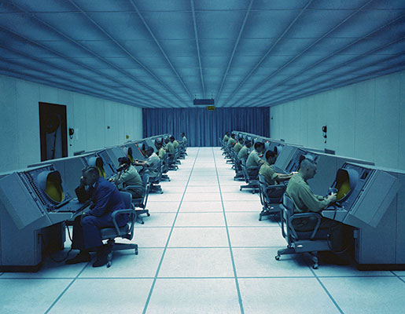
Radar screens on the SAGE system are monitored in what was called the Blue Room.
PHOTO: CANADIAN FORCES MUSEUM OF AEROSPACE DEFENCE—PCN4720

The construction of the Underground Complex (UGC) took four years—one and half years just to excavate and two and a half to build and outfit. By virtue of Canada’s front line position, the Canadian air defence command and control center was deemed the most important piece of the NORAD “pie”, with respect to bombers. (North Bay was never involved in ballistic missile defence.) Its early warning of and reaction against a Soviet nuclear air attack were critical for the survival of the U.S.-Canadian portion of the North American continent. As one air force officer put it: “(regarding a bomber attack) We lose North Bay, we lose the continent.” Ergo, the center was a prime target for a Soviet nuclear strike. To minimize the possibility of its destruction, planners decided to build the facility underground. It would be the only subterranean regional command and control center in NORAD.
Following a cross-Canada survey of candidate sites, North Bay was selected:
- An air force base existed, eliminating the need to build one.
- The City of North Bay was a rail, highway and telecommunications crossroads of the country.
- The geology comprised a 2.6 billion year old rock formation altered 1.5 billion years ago by the Grenville Metamorphic Event into granite, one of the hardest rock types on the planet, excellent armor against a nuclear strike.
- Trout Lake, on the eastern edge of the city, presented an abundant source of water needed to cool the complex.
Because its subterranean location complicated access by firefighting vehicles and personnel, the complex was fashioned from fire-retardant and fireproof materials, making it one of the most fire-safe structures in the country.
What a structure it is: 680 feet underground; three stories tall; can house over 400 people, can stop an atomic bomb; and has two very long entry halls. It is not Superman’s cave, although he would be proud of it. It is the NORAD North Bay Underground Complex, Ontario Canada.
The Norad North Bay Underground Complex is the most extraordinary military installation ever built in Canada. During the Cold War, Canada was in an unenviable geographic position, lying directly between the Cold War’s principal adversaries, the Soviet Union and United States. This meant if the war turned “hot”, Canada would become a major nuclear battleground: to reach their American targets—cities, military bases and industrial installations—Soviet nuclear weapon-armed bombers would have to cross Canadian airspace. Meanwhile U.S. interceptors would swarm the airspace to shoot the attackers down.
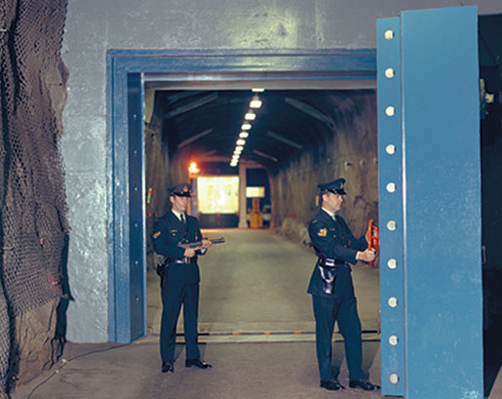
The 19-tonne blast door into the main entrance is opened easily.
PHOTO: CANADIAN FORCES MUSEUM OF AEROSPACE DEFENCE—NBC72-1301

“You had everything you needed there. There was a barber shop, a gym, cafeteria, and doctors’ offices. We assumed that if we had to stay there we could go three weeks or more without needing supplies,” said Marshall Swartz of Bracebridge, Ont., who was stationed at the underground complex three times.
Traffic in the Tunnel
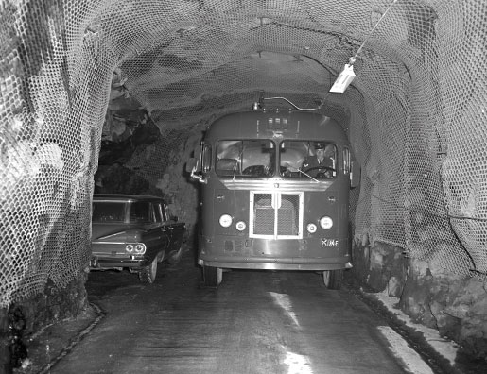
The complex also had all it needed for running a war—a command post, intelligence centre, briefing rooms and a telephone network. It used civilian hydro electricity but had two banks of batteries to provide electricity in case of a power failure. They were backed up by generators that could run on diesel or natural gas.
“We had a reservoir down there for cooling the equipment and the air. We called that our lake. We had a rowboat – and this was our navy.”
But the most impressive credential to the selection committee was its geology. Here was a 2.6 billion-year-old rock formation of granite, one of the hardest rocks on the planet. They built an underground complex 60 storeys beneath the surface, capable, it was believed, of withstanding a four-megaton nuclear blast which would be 260 times more powerful than the atomic bomb dropped on Hiroshima.
The SAGE (Semi-Automatic Ground Environment) system was complex and large. Most of all, it had to operate out of a secure facility. After a Canada-wide survey was conducted, North Bay was selected to house the facility in part because there already was an air force base, eliminating the need to build one. As well, North Bay was a rail, highway and telecommunications crossroads and nearby Trout Lake offered all the water needed to cool the complex.
The UGC cost was $51 million of which Canada paid one third and the U.S. paid the rest. It always had a Canadian in charge and a U.S. officer as second-in-command, mirroring Norad headquarters in Colorado which is overseen by an American general with a Canadian lieutenant-general as his deputy. Canadian and American military personnel started working in the complex Oct. 1, 1963, and continued 24 hours a day, seven days a week until October 2006. “

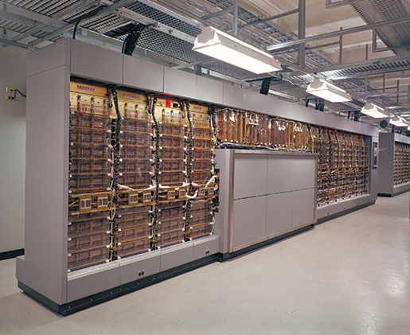
A small section of the SAGE computer.

The SAGE computer system consisted of two huge computers nicknamed Bonnie and Clyde taking up 11,900 square feet. Everything that flew in the northern Norad region had to be identified in two minutes. If not, fighter aircraft, kept fully fuelled and fully armed, were scrambled. The aircraft and the pilots were stationed in a Quick Reaction Alert hangar at the end of the runways. They were expected to be airborne in five minutes.
From the 1950s into the 1990s, the military base was the largest employer in North Bay which today has a population of about 53,000.
The SAGE computers were eventually replaced by the Regional Operation Control Centre (ROCC). It was a more versatile system that was substantially smaller than SAGE and took up floor space equal to about two houses.
Plans to replace the Underground Complex started in the 1990s. Its computer and communications systems were no longer state-of-the-art and the cost of running such a large facility underground was becoming uncontrollable.
A new above-ground building was built and on Oct. 26, 2006, Colonel Rick Pitre, the base commander, led a symbolic parade of complex staff out of the UGC for the last time. During its 43 years of operation, about 17,000 Canadian and U.S. military personnel had worked there.

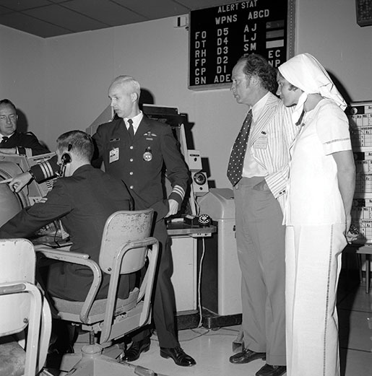
Prime Minister Pierre Trudeau and his wife Margaret tour the underground complex, June 17, 1973.
PHOTO: LIBRARY AND ARCHIVES CANADA—E010858633
A new above-ground building was built and on Oct. 26, 2006, Colonel Rick Pitre, the base commander, led a symbolic parade of complex staff out of the UGC for the last time. During its 43 years of operation, about 17,000 Canadian and U.S. military personnel had worked there.
The Hole is still there but all the equipment and furniture has been taken out. All that remains are the cooling and ventilating systems that only maintenance workers are allowed to visit.
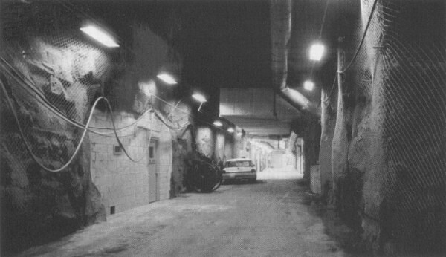
Norad North Bay Under Ground Complex
The complex (which still exists) comprises two sections. The “Main Installation” is a three-story, figure-eight shaped building inside a 430 foot long (131 meter), 230 foot wide (70.1 meter), 5.4 story (54 feet, 16.5 meter) high cave. The “Power Cavern”, which provides life support and utility services to the complex, is a 401 ft. long (122.23 meter), 50 ft. wide (15.24 meter), 2.7 story (27 ft, 8.23 meter) high chamber. Taken together the complex encompasses over 6 million cubic feet.
Access to the complex is via a 6,600 ft. long (2,012 meter) North Tunnel from the air base, and a 3,150 ft .long (960 meter) South Tunnel from the city. The tunnels meet; the idea was if a nuclear weapon struck the air base the blast would shoot down the North Tunnel and out the South Tunnel, minimizing blast damage to the complex and its structures. In fact, the three-story Main Installation is mounted off the ground on specially designed pillars (not springs) to reduce seismic shock—on 1 January 2000, North Bay was rattled like a jar of pennies by an earthquake registering 5.2 on the Richter scale, yet occupants in the Main Installation did not feel a thing.

As an added measure against damage from a nuclear blast, as well as for the security of the installation, the complex is situated behind three 19-ton steel bank vault-type doors. The doors are normally kept open, and shut in times of emergency. Despite weighing as much as a medium-size bulldozer, each door is so well balanced it can be moved effortlessly.

Features of the Norad North Bay Underground Complex
Air defence operations officially began in the UGC on 1 October 1963, and continued around-the-clock, unabated for 43 years until October 2006. There was nothing like it in NORAD (the Cheyenne Mountain Complex did not officially open until 1966) or in Canada, and it attracted world-wide interest. As well as air defence facilities, the Main Installation encompassed a barber shop, small medical center, gym, cafeteria, chaplain’s office, and other amenities for the complex’s personnel (important since the complex was designed to seal up in time of war), plus a command post, intelligence center, briefing rooms, a telephone switching network large enough to handle a town of 30,000 people, and a national civil defence warning center.

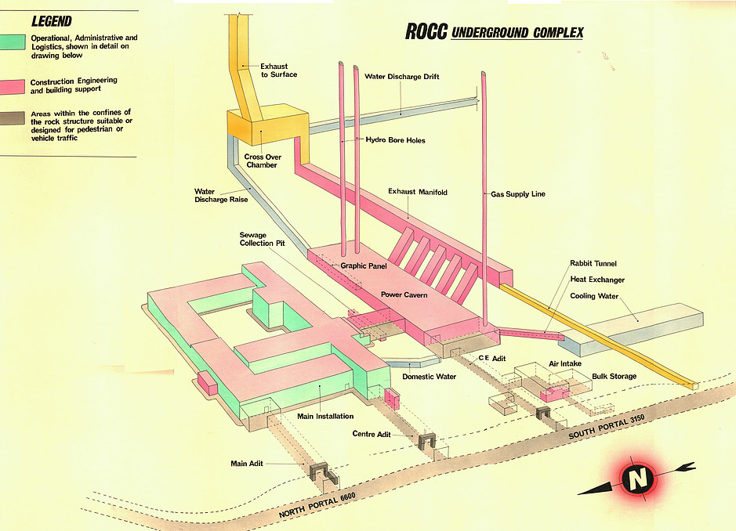

When sealed up, the Underground Complex could support 400 people for upwards of four weeks cut off from the outside world. Since Canada would be the front line for the air defence of North America if the Cold War turned “hot”, it was crucial to ensure that air defence operations would continue as long as possible. A critical factor was electrical power.
Normally, the complex gets its power from the outside civilian hydro-electric grid. In the event of a power failure, such as the August 2003 blackout that hobbled the northeast United States and Canada, two banks of 194 batteries automatically switch on and provide electricity to the complex while an electrical generator is readied to take the load. Once a generator is running, it can power the complex without stopping as long as it has fuel either diesel or natural gas.

CONVERSION ADVANTAGES of this site:
Federally owned facility mothballed for 12 years
Upkeep: $500,000 + annually
NDHQ interested in releasing ownership
Situated beneath 60 storeys of granite
Cooling system utilizes water from a neighbouring lake
Access by road, rail and air
No high-target neighbours or large population centres nearby
Built to world-class standards that may require only minimal upgrades
Space at least double estimated current requirement for media storage
Local construction industry capable of site remediation/customization
Existing data systems can support installation of server(s)
Bilingual college/university infrastructure to support ongoing staffing needs
‘Swords into ploughshares’ optics are timely.

Italics added.
For information on broadcast heritage expenditure in other countries, see Appendix B.
Culture and Entropy, a Lay View of Broadcasting, Graham Spry, 1969.
“The Right to See Everything … Including Ourselves. Pierre Juneau to the Empire Club of Toronto, February 24, 1972.
Hon. Benoit Bouchard, Opening Remarks to the Conference on the Future of the Canadian Broadcasting System, Canadian Conference of the Arts, Ottawa, 1985.
Broadcasting: an Essential Element of Sovereignty and Democracy, Pierre Juneau, October 16, 1985.
Note that national preservation responsibilities of which the national public media service must retain its share, are addressed in Subsection II above.
Interpretation section, Library and Archives of Canada Act, found at https://laws-lois.justice.gc.ca/eng/acts/l-7.7/page-1.html#h-4
The scientific writings of Leonardo Da Vinci
The earliest known 8th century Qur’anic manuscript
A third century collection of 154 craft recipes recorded in demotic Greek.
“The Safeguarding of the Audiovisual Heritage: Ethics, Principles and Preservation Strategies”, 4th Edition, 2017, found at: https://www.iasa-web.org/tc03/ethics-principles-preservation-strategy

