cid:image001.jpg@01D7F19E.FD08D420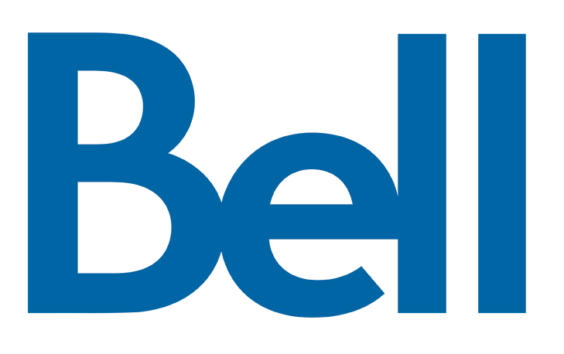

**Reference:** [**1011-NOC2022-0267**](https://services.crtc.gc.ca/pub/instances-proceedings/Default-defaut.aspx?EN=2022-267&Lang=eng&_ga=2.211582230.2033916859.1665496613-1382868148.1650903019)

14 October 2022

Mr. Claude Doucet

Secretary General

Canadian Radio-television and

Telecommunications Commission

Ottawa, Ontario

K1A 0N2

Subject: **Application 2022-0019-5 – Part 1 Application for a condition of licence with respect to section 17.1 of the *Broadcasting Distribution Regulations* – Response to PIAC's Request for an Extension of Time**

Dear Mr. Doucet,

1. Bell Canada, Cogeco, Eastlink and SaskTel (the Applicants) are in receipt of PIAC's correspondence to the Commission regarding our Application to increase the maximum price of the small basic service. While we take no position on whether the deadlines to respond to our Application should be extended, we do wish to correct certain statements made by PIAC in their correspondence.
2. First, we are unclear why PIAC has referred to our Application as a "mystery application" or a "stealth application". Our Part 1 Application, along with our responses to the Commission's requests for information (RFIs), are available on the Commission's website. Like any such application, once it is filed, it is only made available once the Commission publishes it, the timing of which we do not control.
3. Second, PIAC assumes without any evidence that the Applicants have interacted informally with the Commission on our Application. This is false. As the record shows, we filed our Application in January 2022 and responded to a series of RFIs in March 2022 and April, 2022. No other interactions on this file have occurred with the Commission, other than informal inquiries as to when it would be posted for public consultation. PIAC implies that we were able to have an advantage because we knew the Application's content for longer than potential intervenors. Of course, like any applicant, we know the Application's content before we file it and thus can take as long as necessary to draft. Once filed, we had no additional timing advantage that is any different before we filed. In fact, as is evident by the Application, we sought to have a rate increase implemented by April 2022, so the delay has disadvantaged the Applicants rather than benefited us as implied by PIAC.

Yours truly,

[ *Original signed by J. Daniels* ] [ *Original signed by P. Beaudry* ]

**Jonathan Daniels** **Paul Beaudry**

Vice President, Regulatory Law Vice President, Regulatory Affairs

Bell Canada Cogeco Communications Inc.

[ *Original signed by M. Wilson* ] [ *Original signed by W.N. Beckman* ]

**Marielle Wilson** **W.N. (Bill) Beckman**

Vice President, Regulatory Senior Director, Regulatory Affairs

Eastlink SaskTel

c.c.: Stephen Millington, CRTC

PIAC

*** End of Document ***